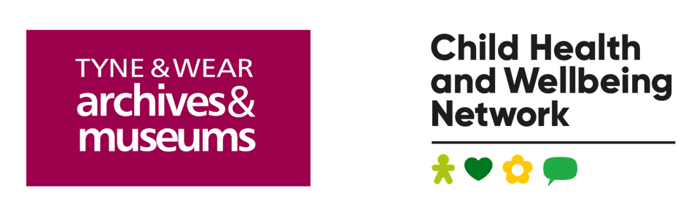

**Chris Drinkwater Creative Health in Primary Schools Award 2024-25**

**Guidance notes for Powerpoint, audio, video or poster submissions**

**Context**

The Chris Drinkwater Awards celebrate creative health partnership projects in primary schools across the North East and North Cumbria. Creative health approaches address health and wellbeing through engagement in creative activities such as dance, drama, visual art, film making, music, heritage to name a few!  The Chris Drinkwater Awards are administered by Tyne & Wear Archives & Museums, in partnership with the North East and North Cumbria Child Health and Wellbeing Network. Winners receive a cash prize to support continuation of their creative health work.

We are particularly interested in learning about the outcomes you have achieved, with emphasis on the evidence you have in regards to improving the wellbeing of young people. This means that we want to know about projects that are completed, or have been running for long enough for evidence of impact to have been gathered.  
  
You can apply by submitting one of the following to [melanie.burgess@twmuseums.org.uk](mailto:melanie.burgess@twmuseums.org.uk) :

* A Powerpoint presentation of no more than 5 slides
* A short audio or video, no more than 5 minutes long
* An A2 poster

If you would prefer to complete our online application form, you can do so here: <https://forms.office.com/e/zvZzviHwQe>   
  
Send in your submission to enter your creative health project to our award programme by **Friday 7 March 2025**.

If you have any questions regarding the application or around creative health please contact us via email: [melanie.burgess@twmuseums.org.uk](mailto:melanie.burgess@twmuseums.org.uk).

Until 31 October 2024, you can also contact one of our Creative Health Champions for further information, advice and guidance on the awards:

Amanda Gould - Queens Hall Arts Centre - [amanda.gould@queenshall.co.uk](mailto:amanda.gould@queenshall.co.uk)Rachel Adamson-Brown - Bigfoot Arts Education - [rachel@bigfootartseducation.co.uk](mailto:rachel@bigfootartseducation.co.uk)Elizabeth Kane - Gateshead Arts Team - [elizabeth_kane81@hotmail.com](mailto:elizabeth_kane81@hotmail.com)Jane Gray - Blue Cabin - [jane@wearebluecabin.com](mailto:jane@wearebluecabin.com)

Kay Harrop - Evergreen Primary - [kharrop@evergreenprimary.co.uk](mailto:kharrop@evergreenprimary.co.uk)

Kate Swaddle - St Joseph's Catholic Junior School, Birtley - [kswaddle@sjjb.bwcet.com](mailto:kswaddle@sjjb.bwcet.com)

Wendy Kelly - Public Health South Tees - [wendy_kelly@middlesbrough.gov.uk](mailto:wendy_kelly@middlesbrough.gov.uk)

Martin Wilson – Arts & Creativity Advisor – [martin@tinarts.co.uk](mailto:martin@tinarts.co.uk)

Heather Corlett – Network lead - [hcorlett@nhs.net](mailto:hcorlett@nhs.net)

**What to include in your submission**

All applications are scored against the following criteria:

* Initiative involves a primary school in the North East & North Cumbria geographic area
* The school serves a local population in an area with a high level of deprivation
* Initiative promotes creative health benefits through any form of the arts
* Initiative involves a primary school and a cultural organisation/ artist working in partnership
* Demonstrates an approach to address social and emotional learning to improve health and emotional outcomes
* Inclusion of family support or involvement
* Provides evidence of feedback from pupils, teachers and families in the application
* Provides evidence of evaluation of impact of the initiative in the application
* Creative health benefits and outcomes were highlighted in the application
* Shares an outline of how the work was funded
* There is an opportunity for sustainability and spread of the project

If you are sending us a Powerpoint, audio or video submission, please make sure that you include the following information in your covering email:

* Name of person applying for the award
* Job title
* Email address
* Name of primary school involved in the project
* Postcodes of school(s) involved in the project
* Contact name and email address for school project lead
* Name of cultural organisation/ artist involved in the project
* Contact name and email address for cultural organisation/ artist project lead