Introduction
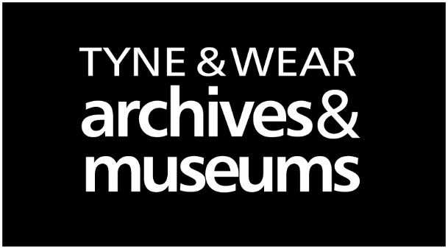
Tyne and Wear Archives and Museums
HEALTH AND SAFETY CODE OF PRACTICE:
TWM 05

Issue: January 2019

PLANNING AND MANAGING GROUP VISITS TO MUSEUMS AND GALLERIES

Distribution: To be brought to the attention of all Learning and Front of House staff and teachers, parents and other helpers supervising group visits.

It is to be hoped that group visits to any of the venues or site of Tyne & Wear Archives and Museums will be educational, exciting and enjoyable. The health and safety guidance notes below are designed to help the organiser plan and manage visits as safely as possible.

General Safety
When moving around the building please ensure that participants in the group walk, and do not run or climb. There are hazards such as stairs, pillars, objects and display cases, walking will reduce the risk of collisions, slips, trips and falls.
Some exhibits have been fitted with safety guards or barriers and visiting groups need to be reminded, not to remove, interfere with, or try to reach beyond the barriers provided for their safety. Please look on the Museum/gallery website and refer to the hazard identification sheet when planning your risk assessment.

Group Activities and Workshops
Every effort is made to ensure activities are designed to be suitable for the age range and abilities of the participants in the group. When using equipment such as pens, pencils, scissors or paint please remind your group of the need to use the equipment in a careful and sensible way to avoid accidents and injuries.

All group sessions involving handling objects, tools or specialist equipment issued by museum staff will begin with a safety talk concerning the correct use of the equipment which is going to be used.
Please inform museum staff in advance if there are any participants in the group requiring additional support and the nature of their needs, so that we can ensure that all participants can be provided the best possible experience.

Supervision
Please remember that it is the organiser’s responsibility to supervise the behaviour and oversee the activities of the group while within the museum. The organiser needs to ensure that their arrangements conform to their governing body or appropriate LEA guidelines particularly in ensuring the adult/child ratio for supervision is appropriate.

Please ensure that all adult helpers are prepared for the visit and receive a copy of this information sheet and all support material provided by TWAM for the visit.

Accidents and Emergencies
If anyone in the group is involved in an accident, no matter how minor, please contact a member of museum staff immediately and they will ensure that the necessary steps are taken.

If the fire alarm sounds please make your way calmly via the nearest emergency exit to the assembly point. Front of House staff will supervise the evacuation of the building.

